Quizzes correct?
Exercise 1(slide 9) doesn’t have proper instructions on the slides, just step by step guide on slides.. also confused about exercise 2(slide 18)
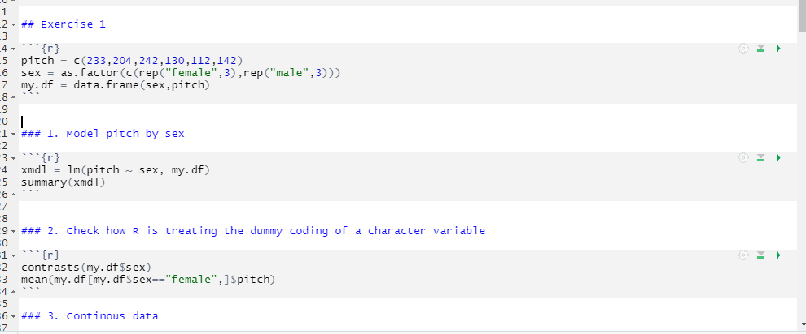
Exercise 2 seems to be in two parts, some on slide 18, some on 21

